Special Compass Foundation

Sponsorship Package
Special Compass (www.SpecialCompass.org) is a 501(C)3 Not for Profit organization whose mission is to improve the lives of disabled persons through sport and independent living. Special Compass has served in fund-raising bicycle events and activities ranging from 5k’s, Obstacle Course Races to Ironman Triathlons.
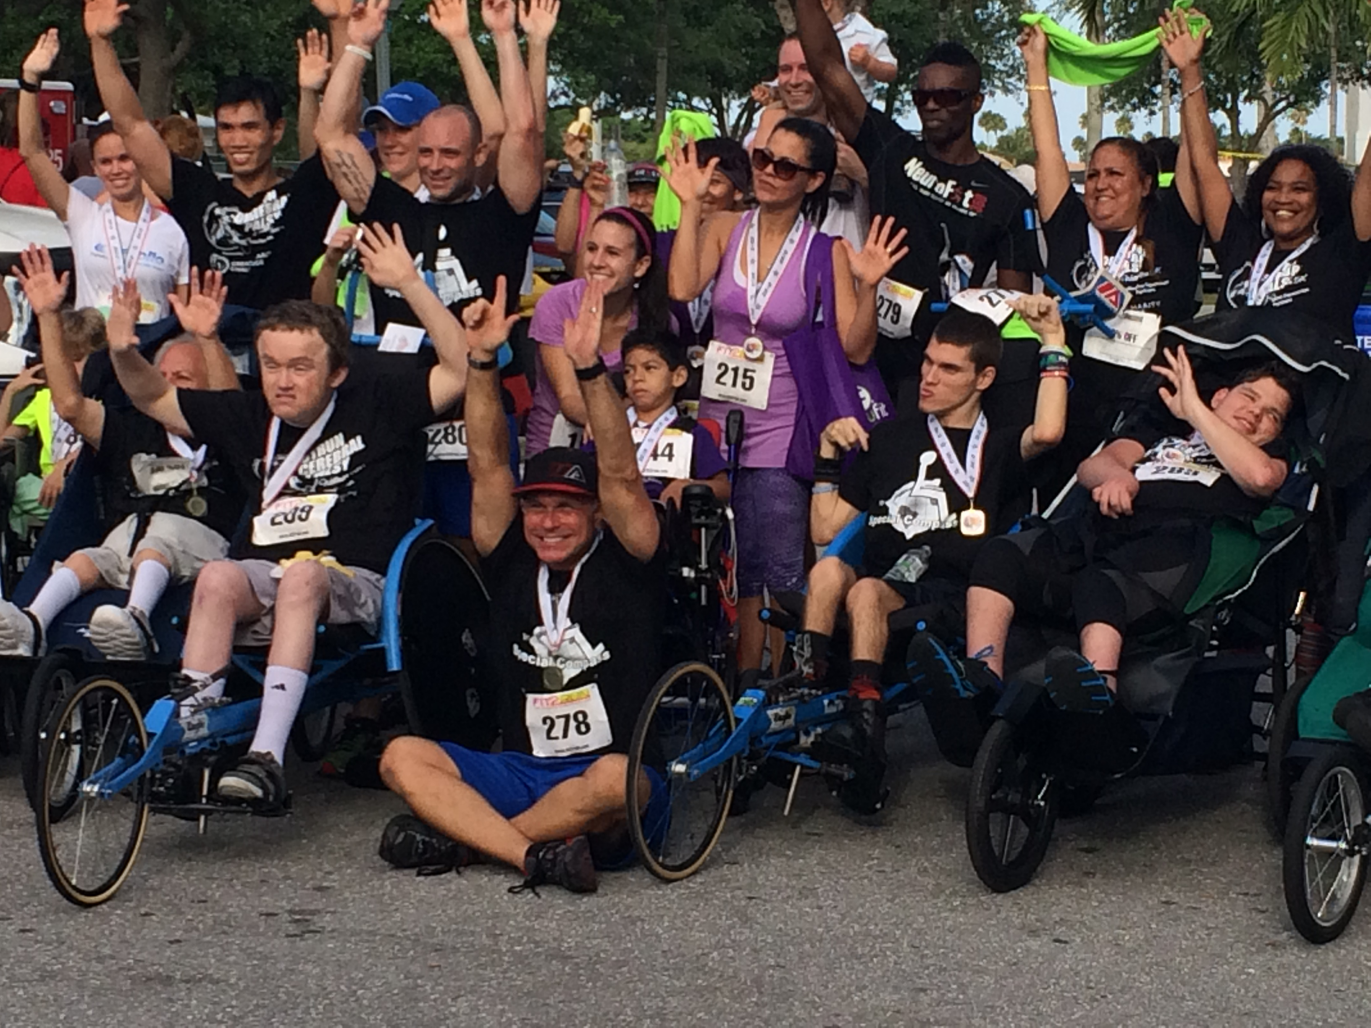
Through its programs, Special Compass provides race equipment, training and race day needs to those we serve. Through the programs we hope to teach both participants and volunteers that the disability of our athletes does not need to limit what they can’t do. But rather, show them what they can do. Taken directly from our inspiration, Founder Michael Sayih, we continue to provide an experience that our families continue to thrive on. We do not look for separate opportunities but believe that those directly benefiting from our programs should experience endurance events in the same manner that all who participate do. Last year through our programs Special Compass was aired on ESPN during the FIESTA BOWL as we were highlighted as a Racing Team in the BattleFrog, Navy Seals Obstacle Course. Also, Special Compass was featured in Spartan Race, Ironman Miami, Dolphins Cancer Challenge and more. We are adding a camp to allow families we serve an opportunity to learn about our foundation while enjoying a camp experience.
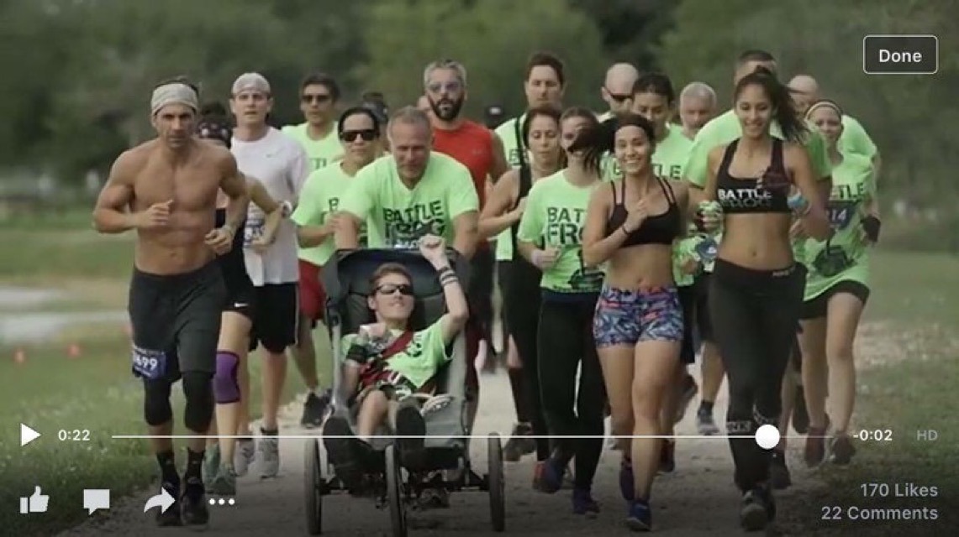
2016 Sponsorship Summary
We welcome your organization to partner with Special Compass so that all athletes can reach the start line and participate in athletics with no restrictions. We invite you to help grow the programs of Special Compass and share that within your organization, and those you encounter in your professional field.
All sponsors, regardless of participation level will receive:
- Email recognition to all subscribers of Special Compass
- Social Media Promotion across all platforms of Special Compass
- Acknowledgement at annual Gala Dinner fundraiser
Platinum $10,000 & above
- One (1) Speaking opportunity from Michael & Jim Sayih to your organization and one (1) speaking opportunity at a partner organization from Michael & Jim Sayih (if desired)
- Opportunity for video or marketing promotion at annual fundraiser
- Prominent placement on all Cycling & Triathlon apparel (front & rear)
- Larger Logos on all printed clothing material (including cycling & triathlon).
- Link to company website through SpecialCompass.org and links to all social media pages
- Email and social media recognition of partner company
- Recognition at Gala Dinner fundraiser
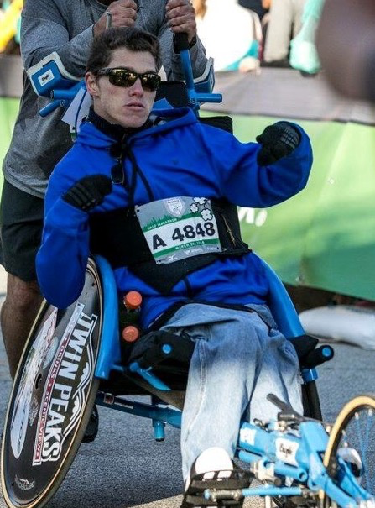

Gold $7,500
- One (1) speaking opportunity of 30 minutes from Michael & Jim Sayih
- Logos on rear of all printed clothing material (including cycling & triathlon).
- Link to company website through SpecialCompass.org and links to all social media pages
- Email Recognition and social media promotion of company
- Recognition at Gala Dinner fundraiser
Silver $5,000
- One (1) speaking opportunity of 10 minutes from Michael & Jim Sayih
- Logos on all running apparel
- Link to company website through SpecialCompass.org and links to all social media pages
- Social Media Promotion of Company & email recognition
- Recognition at Gala Dinner fundraiser
Bronze $2,500
- One (1) speaking opportunity from a Special Compass sponsored athlete (one of the athletes who has raced with Special Compass in the last 12 months).
- Logos on Gala Dinner shirt
- Link to company website throughSpecialCompass.org and links to all social media pages
- Recognition at Gala Dinner fundraiser
Sponsorship $1000
- Logos on Gala shirt & recognition at Gala Dinner fundraiser
- Link to company website through SpecialCompass.org and links to all social media page
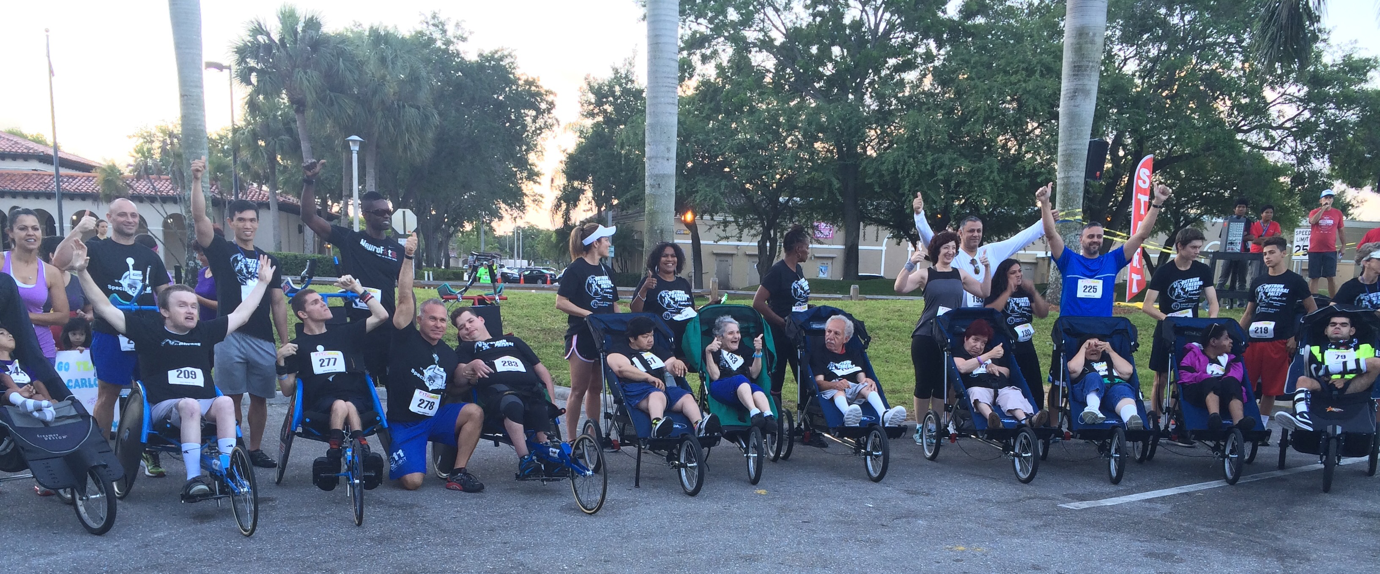

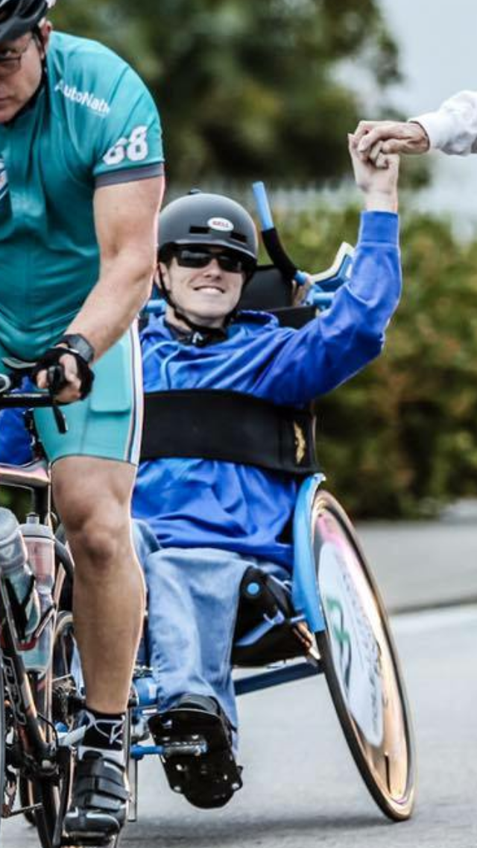

For more information, please contact:
Jim Sayih 305-297-5328 Info@SpecialCompass.org

Competing Against Yourself is Never a Game; It’s The Game Changer – Michael Sayih

